**Discovery 1: Investigate the CAM**

**Introduction**

Through this discovery, you will investigate the contents and properties of the CAM table of a switch. You can display the CAM table to verify the information that the switch has learned. The table will also tell you out of which port the address was learned, along with the VLAN information.

Task 1: Investigate the CAM

**Activity**

**Step 1:** From PC1, generate traffic to all devices in the subnet.

Log on to PC1 and issue a broadcast ping to 10.1.1.255. Configure a repeat count of 10 and a datagram size of 1500.

Pinging the broadcast address of 10.1.1.255 will ping all hosts in the 10.1.1.0/24 subnet. You are doing this action in order for Switch1 to learn all the MAC addresses of connected hosts.

When issuing a broadcast ping, you will need to make sure that you are in privileged mode. IP broadcast pinging is disallowed from user EXEC mode.

Note

In the IOL environment, PCs are simulated using routers.

On PC1, enter the following commands:

PC1>

PC1> enable

PC1# ping Protocol [ip]: <Enter>

Target IP address: 10.1.1.255

Repeat count [5]: 10

Datagram size [100]: 1500

Timeout in seconds [2]: <Enter>

Extended commands [n]: <Enter>

Sweep range of sizes [n]: <Enter>

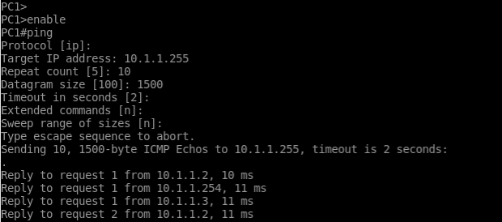

**Step 2:** Access Switch1 and investigate its CAM table.

Use the **show mac address-table** command.

Notice that you see one MAC address per port for Gigabit Ethernet 0/1, 0/2, and 0/3. These interfaces are the ports that PC1, PC2, and PC3 connect to, respectively.

On Switch1, enter the following command:

Switch#show mac address-table

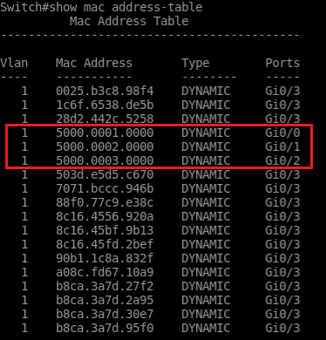

So, if PC1 sends a packet to PC2, Switch1 will receive it on Gigabit Ethernet 0/1. Switch1 will investigate the frame and see that the destination MAC address is that of PC2. Switch1 will now perform a lookup and find the MAC address of PC2 mapped to Gigabit Ethernet 0/2. For the final step, Switch1 will forward the message.

**Step 3:** On Switch1, filter out MAC addresses that the switch learned through Gigabit Ethernet 0/3.

Use the command **show mac address-table interface Gigabit Ethernet 0/3.**

Switches that connect to many devices can have very long CAM tables. In those cases, you can help yourself with filtering.

You can see that Switch1 sees two MAC addresses through port Gigabit Ethernet 0/3:

On Switch1, enter the following command:

Switch#show mac address-table interface GigabitEthernet 0/3

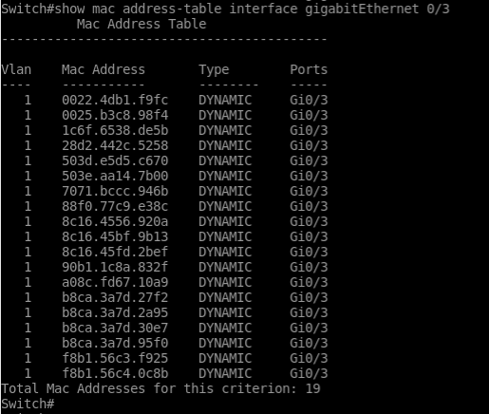

You can add the address keyword to specify a single MAC address. If you want to show just MAC addresses that belong to devices in a certain VLAN, add the vlan keyword.

**Step 4:** How is it possible for Switch1 to see two MAC addresses through port Gi0/3?

Switch1 sees two MAC addresses through Gigabit Ethernet Gi0/3 because this port connects to another switch.

**Step 5:** Issue the show cdp neighbor command on Switch1.

You can verify that Switch1 connects to another switch by investigating its Cisco Discovery Protocol neighbors. Use the show cdp neighbor command. Cisco Discovery Protocol is used to share information about directly connected Cisco equipment.

On Switch1, enter the following command:

Switch#show cdp neighbors

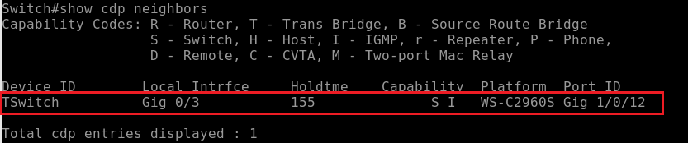

CAM Aging Time

CAM tables can accommodate a lot of entries for frame forwarding. However, there is not enough space for every address in a large network. For that reason, addresses that have not been heard from for a time (stale entries) are aged-out. That time is also called aging time.

**Step 6:** Investigate aging time using the show mac address-table aging-time command.

By default, the aging time is 300 seconds:

On Switch1, enter the following command:

Switch#show mac address-table aging-time

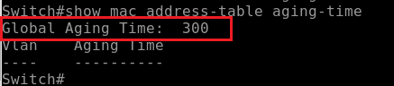

The default aging time for ARP table entries is 4 hours. In networks where you have a host that does not generate a lot of traffic for long periods of time, you can have your CAM table entries time out every 5 minutes. In these rare cases, you might have to increase the CAM aging time to bring down the amount of flooding.

CAM table entries cannot be summarized the way that they are in IP routing. Having 1000 devices in the network means 1000 addresses per CAM table per switch. When the CAM table is full, the switch acts as a hub by forwarding all new frames, like broadcasts. The solution is to implement routing into the network to limit MAC flooding.

**Step 7:** Change the CAM aging time on Switch1 to 600 seconds.

The default setting of the CAM aging time can be changed using the following command: mac address-table aging-time seconds. Change the aging time on Switch1 to 600 seconds.

On Switch1, enter the following command:

Switch(config)#mac address-table aging-time 600



**Step 8:** Now, after you have changed the aging time, verify the change using the command show mac address-table aging-time:

On Switch1, enter the following command:

Switch#show mac address-table aging-time

